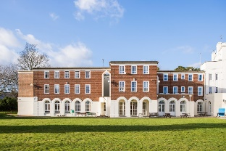 | 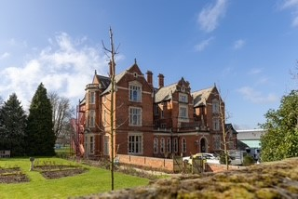 |  | 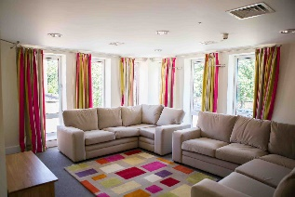 |  | 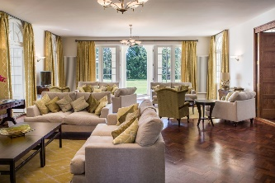 |  | 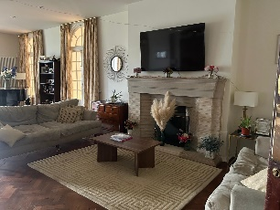
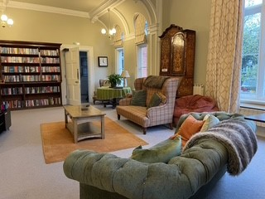 |  | 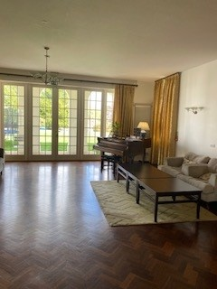 |  | 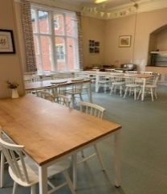 |  | 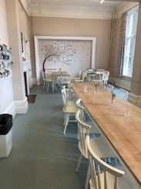 |  | 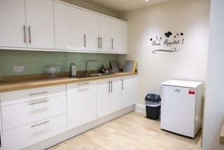
CHELTENHAM LADIES COLLEGE
- Very close proximity to The Town Hall, Cheltenham

- Very clean, very modern looking building inside and outside.

- The ground floor consists of communal lounges, a music room with piano, dining rooms, fully equipped kitchens (if self-catering) – parquet flooring through-out.

- The shared bathrooms (with individual shower cubicles) and shared bedrooms are all situated on the first floor.

- Bedrooms are much larger than usual twin hotel rooms.

- Bedrooms will be cleared of all students possessions and each bed has its own wardrobe.

- Towels and bedding are provided.
Prices - Single occupancy
Dinner/Bed/Breakfast/Lunch – total £105
Dinner/Bed/Breakfast – total £96
Bed/Breakfast - £78
If sharing a bedroom, please deduct £12 per person from the above prices.
You are welcome to BYOB. We have sample menus available upon request.
Other important notes to highlight:-
- Minimum number required for Inner Wheel to proceed with the booking is 30 and we need to reach this number by 15th November latest. There will be flexibility over the bookings once the target 30 is reach and the maximum could be 80-100 if single occupancy or 180-200 if rooms are shared.
- Bedrooms do not have any keys. The buildings themselves are very secure and access will be via key cards, but there isn’t the option to lock individual rooms.
- Members need to be able bodied as there are quite a few stairs!
If interested or for more details, please contact Deputy Hostess Kath Brown on e-mail address kathleenbrown796@hotmail.com or telephone: 01229 465782.
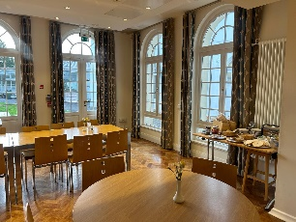 | 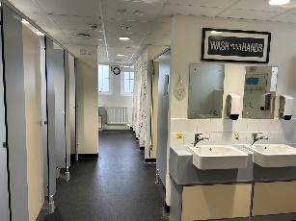 | 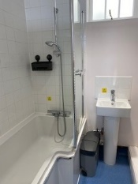 | 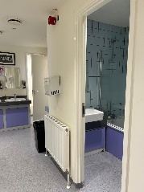 | 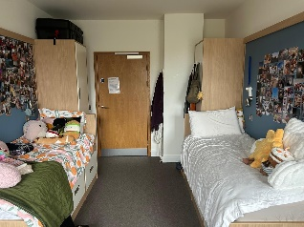 | 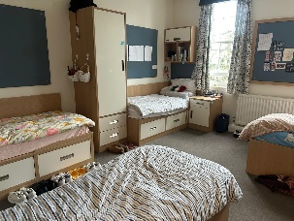

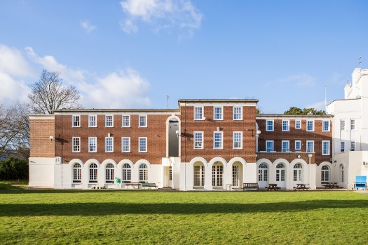 |  |  | 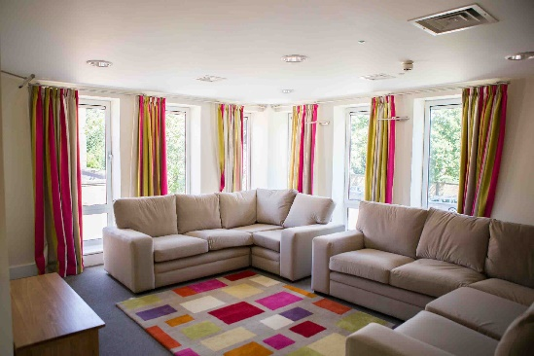
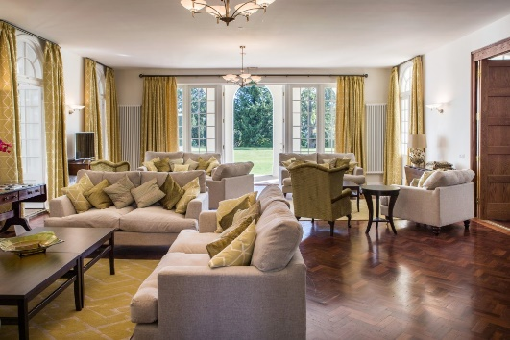 |  | 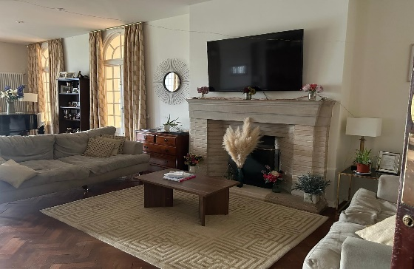
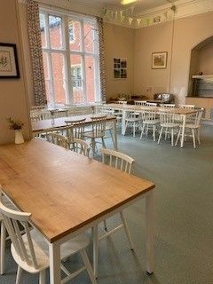 |  | 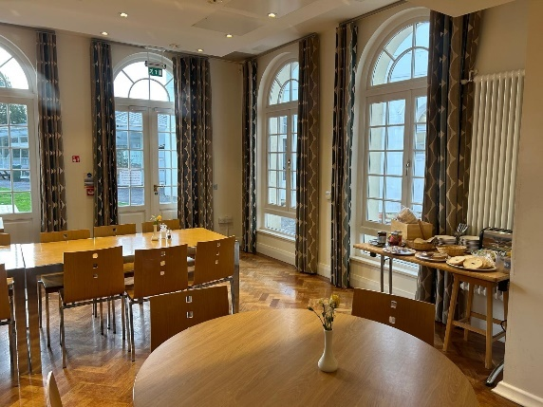
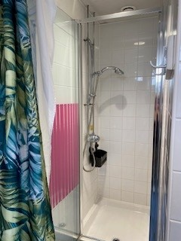 |  | 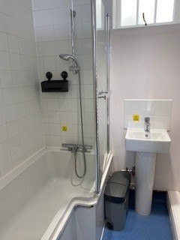 | 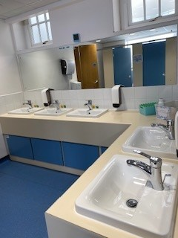
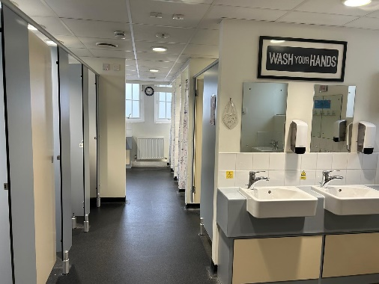 |  | 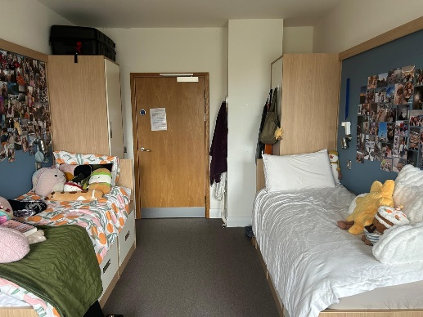 | 